Universidad Nacional Autónoma de México

Facultad de estudios Superiores Aragón

Ingeniería en Computación

Área: Ciencias de la Computación

Materia: Estructura de Datos

Profesor: Roberto Blanco Bautista

Título: Pila y Cola (Stack and Queue)

Alumno: Hernández Gorgonio Henry

Grupo: 2307

Fecha: 15/04/2022

Stack and Queue

Stack (Pila)

In computer science a stack is an abstract data structure consisting of a collection of elements following the LIFO (Last In First Out) principle, its two principal operations are:

1. Push: adds an element to the top of the collection
2. Pop: removes and returns the top element in the collection

Additionally, some stacks implement de “peek” operation, which gives access to the top element without modifying the stack (not removing it).

The name stack, comes from the analogy to a set of objects stacked on top of each other, in which the last element stacked is the firs on being removed.

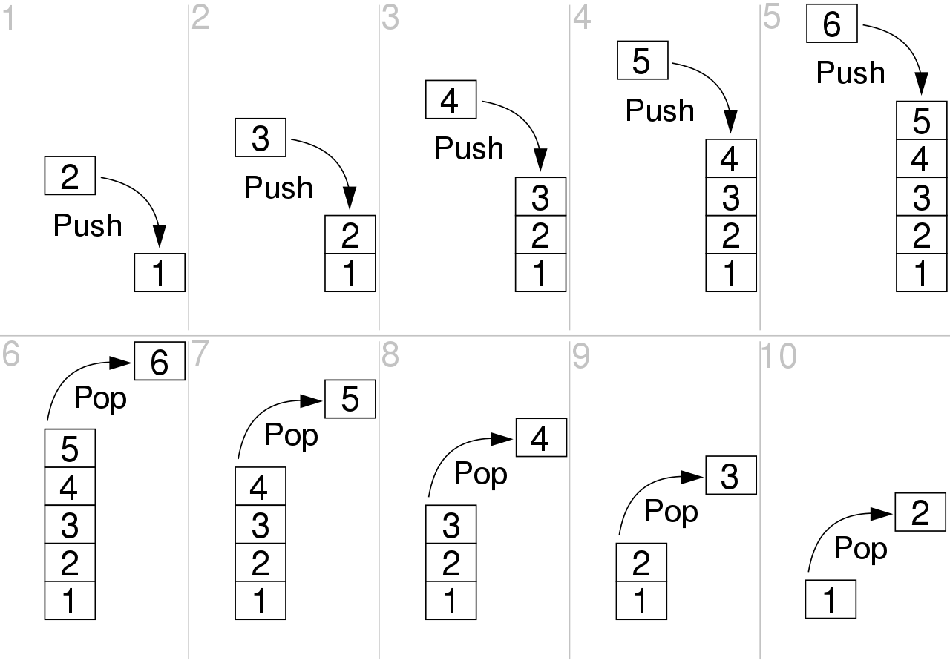

The image above shows a representation of the stack data structure and it principal operations

Queue (Cola)

In computer science, a Queue is an abstract data type that serves as a collection of elements following the FIFO (First In, First Out) principle, the collection can be modified by adding elements at one of the ends of the sequence and by removing elements at the other end. By convention, the side by which the elements can be added is called back, tail or rear. The side by which the elements can be removed is called head or front.

The Queue data structure performs two principal operations:

1. Enqueue: adds an element at the back of the queue.
2. Dequeue: removes and returns an element from the front of the deque.

Additionally, a third operation can be implemented:

1. Peek: gives access to the next element to be dequeued, without removing it from the queue.

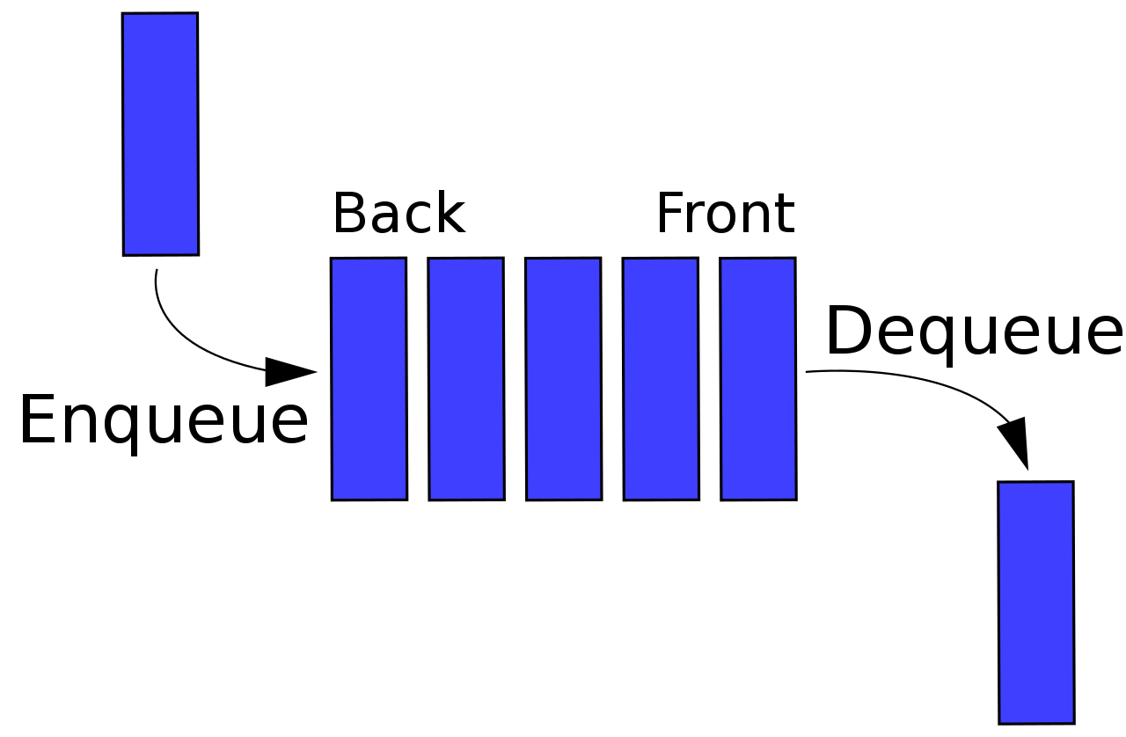

There are two principal implementations of this type of data structure: using Linked Lists and using arrays. I’ve chosen the array implementation, with a non-fixed size, this will be achieved by dynamically changing the array size.

Deque

In computer science, a double-ended queue, is an abstract data type that serves as a collection of items where the sequence of items can be modified by adding or removing at either the back or the front of the collection. It is a generalization of de Queue data structure.

There are two common implementations: with a dynamic array or with a double linked-list.

Since the Deque is just a generalization of the Queue and Stack, we’ll implement these two subtypes by programming a Deque using arrays.

Flow Chart

* Stack
  + Variables:
    - items: is the inner array, it is a generic array of Objects
    - size: Integer data type variable to track the size of the Stack
    - nextFirst: is the pointer to the position of the next element to be inserted at the front
    - nextLast: is the pointer to the position of the next element to be inserted at the back
    - toReturn: is a variable to store the object to be returned in a Pop operation.



* Queue
  + Variables
    - items: is the inner array, it is a generic array of Objects
    - size: Integer data type variable to track the size of the Stack
    - nextFirst: is the pointer to the position of the next element to be inserted at the front
    - nextLast: is the pointer to the position of the next element to be inserted at the back
    - toReturn: is a variable to store the object to be returned in a Pop operation.



UML Diagram



User Interface

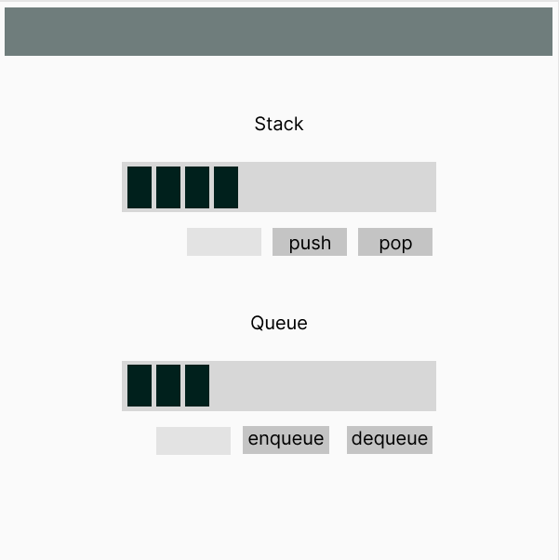

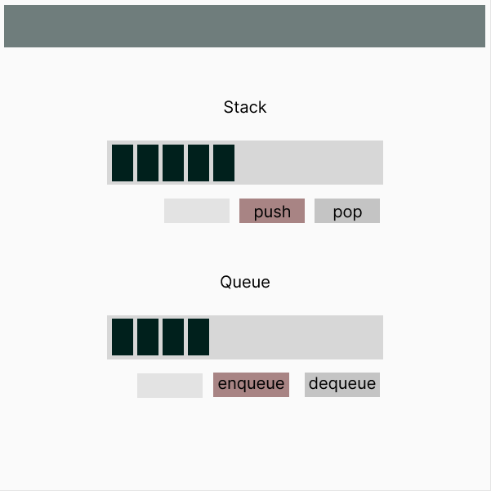

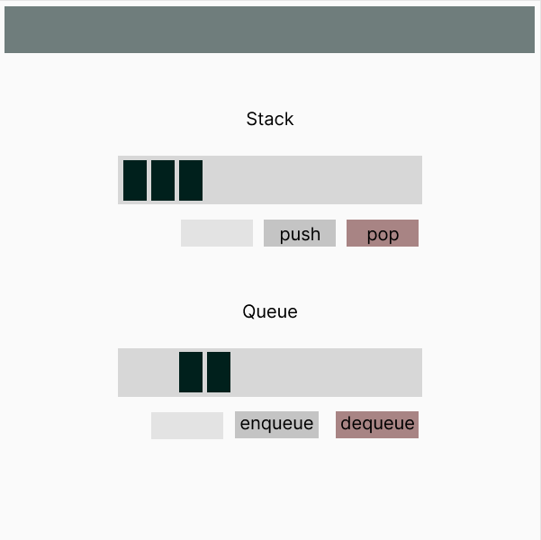

Codebase

Results